Project Proposal
AI Driving Monitoring System Using rPPG Blood Oxygen Level, and Pulse Detection
Supervisor:
Professor Chau Yun Hsu
Member:
Chang Shan-Wei
- Introduction
Road safety remains a pressing global issue, with driver fatigue, distraction, and impairment being major contributors to accidents. While current driver monitoring systems—such as those tracking steering behavior or eye movement—offer useful data, they often fall short in assessing the driver's full physiological and emotional state.
Recent advances in artificial intelligence and computer vision, especially non-contact techniques like remote photoplethysmography (rPPG) using standard RGB cameras, open new doors for safer driving. This research explores how these tools can be used to monitor drivers in real time—without the need for intrusive sensors—by extracting multiple physiological signals such as heart rate, oxygen saturation, and facial expressions.
Although existing systems provide some behavioral insights, few offer truly non-invasive, multi-modal monitoring capable of detecting a driver's readiness to drive in complex environments. Our approach aims to close this gap by developing a camera-based system that integrates diverse biological cues to enable earlier and more reliable interventions.
Literature Review
The main journal that will help this research is “AI Innovations in Rppg Systems for Driver Monitoring: Comprehensive Systematic Review and Future Prospects” [1].
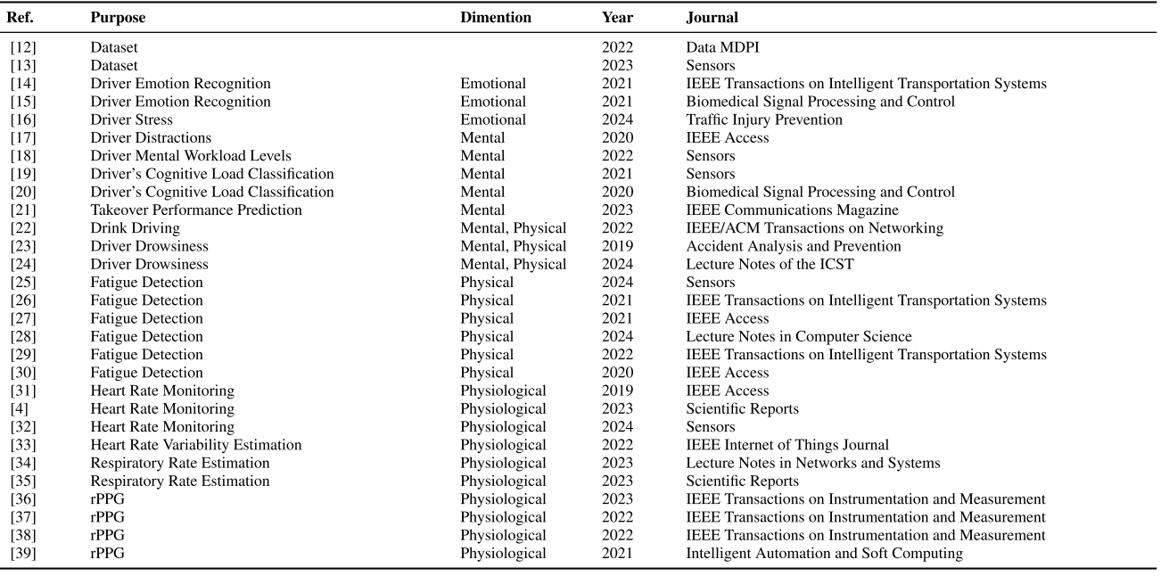
The second table is a quick comparison of experimental setup across studies in rPPG signal extraction. The journal demonstrates all the focus, pros, and cons of each paper. The table also shows the hardware system setup for each of the research, which can give a general idea of the current driver monitoring system trend. This also allows us to setup the our subject, dataset, camera, ground truth, environment, and condition tested.
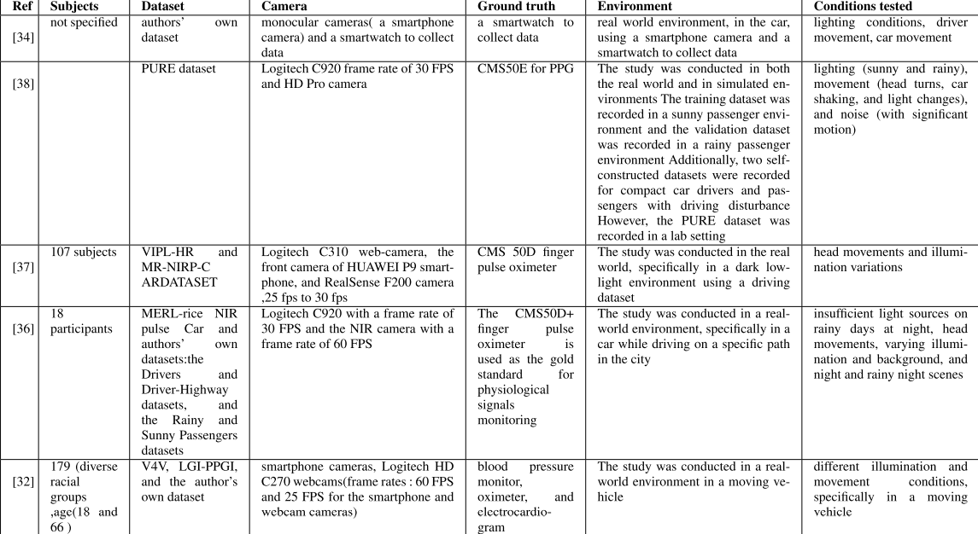
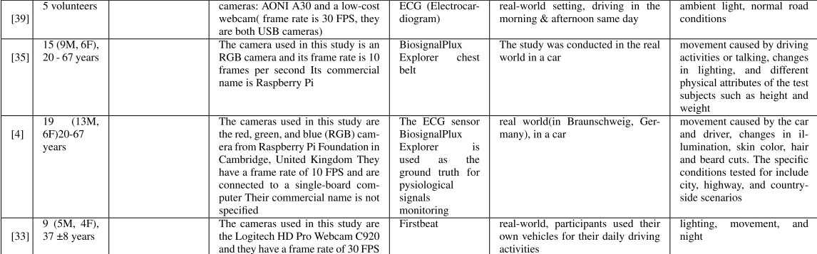
Research Problem
Research Gaps:
- Integration of Multi-Modal Data: While there has been progress in using rPPG and computer vision for physiological monitoring, there is limited research on effectively integrating multiple physiological signals (e.g., heart rate, oxygen saturation, facial expressions) in real-time. Understanding how these signals interact and contribute to a comprehensive assessment of driver readiness remains an open area for exploration.
- Contextual Adaptation of Monitoring Systems: Current driver monitoring systems often do not account for varying driving conditions and contexts (e.g., urban vs. rural, day vs. night). Research is needed to develop adaptive algorithms that can modify monitoring parameters based on environmental factors and driving scenarios to enhance accuracy and reliability.
- Longitudinal Studies on Driver Behavior: Most studies focus on short-term monitoring and data collection. There is a gap in longitudinal research that examines how driver fatigue, distraction, and impairment evolve over time and how physiological signals correlate with these changes. This could lead to more effective predictive models for driver readiness.
- Emotional State Assessment: While some systems assess basic physiological signals, there is a lack of comprehensive research on how emotional states (e.g., stress, anxiety) can be accurately detected and quantified through non-invasive methods. Understanding the emotional dimensions of driver behavior could significantly enhance safety interventions.
- User Acceptance and Ethical Considerations: The implementation of non-invasive monitoring systems raises questions about user acceptance and privacy. Research is needed to explore drivers' perceptions of such technologies, ethical implications, and how to design systems that respect privacy while ensuring safety.
- Real-World Testing and Validation: Most advancements in driver monitoring systems are tested in controlled environments. There is a need for extensive field studies to validate the effectiveness of these systems in real-world driving conditions, including diverse populations and varying traffic scenarios.
- Impact of Cultural Factors: Different cultures may have varying attitudes towards technology, privacy, and driving behaviors. Research is needed to understand how cultural differences can affect the acceptance and effectiveness of non-invasive monitoring systems in different regions.
- Machine Learning Algorithm Transparency: As artificial intelligence plays a significant role in processing physiological data, there is a gap in understanding the transparency and interpretability of these algorithms. Research could focus on developing explainable AI models that provide insights into how decisions regarding driver readiness are made.
- Personalization of Monitoring Systems: Individual differences in physiology and driving behavior are often overlooked. Future research could explore how to personalize monitoring systems to account for individual variances in physiological responses, potentially leading to more accurate assessments of driver readiness.
- Integration with Vehicle Systems: There is limited research on how driver monitoring systems can be integrated with existing vehicle safety systems (e.g., collision avoidance, adaptive cruise control) to create a holistic approach to road safety. Exploring synergies between these technologies could enhance overall vehicle safety.
Research Questions:
RQ1: How effective are non-contact techniques, such as remote photoplethysmography (rPPG), in accurately measuring physiological signals relevant to driver fatigue and impairment?
RQ2: What specific physiological signals (e.g., heart rate, oxygen saturation) can be reliably extracted from drivers using standard RGB cameras (or IR camera or hybrid)in real-time monitoring systems?
RQ3: How do facial expressions correlate with a driver's emotional state and readiness to drive, and can these correlations improve road safety interventions?
RQ4: In what ways can multi-modal non-contact monitoring systems enhance the detection of driver distraction and fatigue compared to traditional driver monitoring systems?
RQ5: What are the potential limitations and challenges of implementing non-invasive, camera-based monitoring systems in real-world driving environments?
Environment is a big issue with the current system. (light, dark)
Movement detection before driving to ensure the safety of the driver. The research needs to consider drivers’ readiness. (G sensor)
RQ6: How can the integration of diverse biological cues from non-contact monitoring systems lead to earlier interventions for at-risk drivers?
RQ7: What factors influence the accuracy and reliability of physiological signal extraction in varying driving conditions and environments?
Camera fps, environment, lighting, etc.
RQ8: How do driver perceptions of privacy and comfort affect the acceptance and use of non-invasive monitoring technologies in vehicles?
RQ9: What role does artificial intelligence play in improving the interpretation of physiological and emotional data for real-time driver monitoring?
RQ10: How can the findings from this research inform the design of future driver assistance systems aimed at enhancing road safety?
Objectives
Outcome expectations for this project will be a complete implementation of the system. This system will be able to operate with multiple hardware. Here is a block diagram for the driver monitoring system.
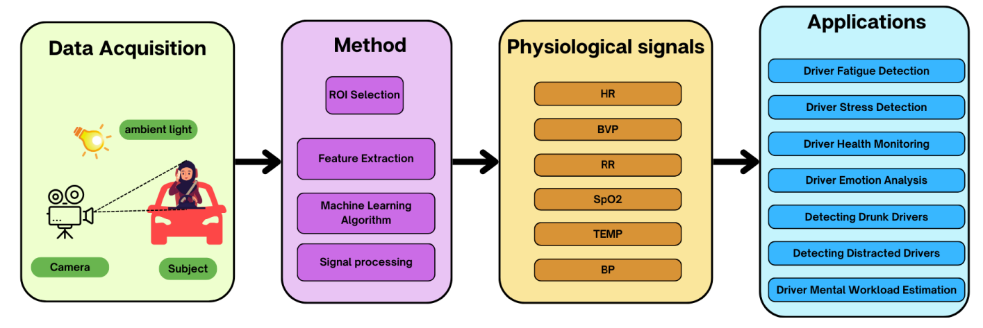
Specifically, video cameras and deep learning are used to monitor driver physiological signals and vital signs such as heart rate (HR), oxygen saturation (SpO2), respiration rate (RR), Blood (BP) and temperature (TEMP).
Also, machine learning algorithms have been widely used in the research of Rppg driver monitoring system. Here is a figure showing the algorithm models that are implemented in previous research. For this research, we will focus on using CNN, LSTM, NN, and possibly RNN.
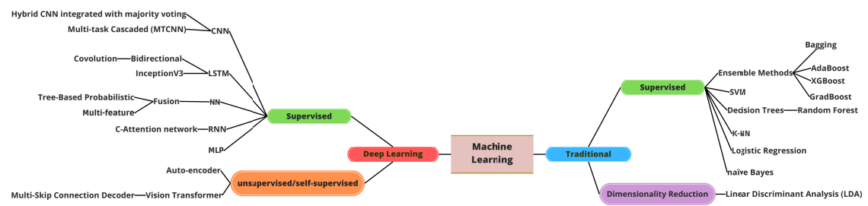
Our project will be set up with the following: subject, dataset, camera, ground truth, environment, and condition tested.
Our project will be conducted firstly in Tatung University. Besides the research group, we will find test subjects in school for early phase. In later phase of the project, we can collaborate with the company. For the camera we will possibly use RGB camera and IR camera. This can be adjusted based on the equipment provided. For the ground truth, we will use a pulse oximeter, such as model CMS50E. For environment, we will be conducting tests in real life environments, and with various lighting and temperature conditions.
Theoretical Framing
1. Human Factors and Ergonomics Theory
- Description: This theory focuses on understanding human capabilities and limitations in relation to the design of systems and processes. It emphasizes optimizing the interaction between people and technology.
- Application: This framework can be used to evaluate how driver monitoring systems can be designed to accommodate human physiological and emotional states. It can help identify critical factors in driver behavior, fatigue, and distraction, ensuring that technology supports rather than hinders safe driving.
2. Cognitive Load Theory
- Description: This theory posits that cognitive resources are limited, and excessive cognitive load can impair performance. It is particularly relevant in contexts where attention is divided, such as driving.
- Application: You can leverage this theory to assess how driver monitoring systems can detect signs of cognitive overload through physiological signals. Understanding the cognitive load can inform the design of alerts or interventions when a driver is at risk of becoming overwhelmed or distracted.
3. Biopsychosocial Model
- Description: This model integrates biological, psychological, and social factors to understand health and behavior. It recognizes that multiple dimensions influence a person's state and performance.
- Application: Your research can utilize this model to develop a holistic understanding of driver readiness by incorporating physiological signals (biological), emotional states (psychological), and environmental factors (social). This comprehensive approach can enhance the effectiveness of monitoring systems.
4. Technology Acceptance Model (TAM)
- Description: TAM explains how users come to accept and use technology, focusing on perceived ease of use and perceived usefulness.
- Application: This framework can guide the evaluation of user acceptance of the non-contact monitoring systems you develop. Understanding how drivers perceive the usefulness and usability of technology will be crucial for successful implementation and adoption.
5. Situational Awareness Theory
- Description: This theory emphasizes the importance of perceiving, comprehending, and predicting elements in the environment to make informed decisions.
- Application: The monitoring system can be framed within this theory by assessing how well it enhances drivers' situational awareness through real-time physiological feedback. It can help identify when drivers are losing awareness due to fatigue or distraction, allowing for timely interventions.
6. Self-Regulation Theory
- Description: This theory focuses on how individuals control their thoughts, emotions, and behaviors to achieve personal goals. It highlights the importance of self-monitoring and feedback in regulating performance.
- Application: The research can explore how physiological feedback from the monitoring system can empower drivers to self-regulate their state, encouraging them to take breaks or adjust their driving behavior based on real-time data about their readiness.
7. Theory of Planned Behavior (TPB)
- Description: TPB posits that individual behavior is driven by intentions, which are influenced by attitudes, subjective norms, and perceived behavioral control.
- Application: This theory can guide the exploration of how drivers' intentions to engage in safe driving practices can be influenced by the feedback provided by the monitoring system. Understanding the factors that shape drivers' attitudes toward using such technology can inform design and implementation strategies.
8. Systems Theory
- Description: This theory views systems as complex networks of interrelated components. It emphasizes the interactions and relationships within the system.
- Application: The driver monitoring system can be analyzed as part of a larger transportation safety system. This framework can help identify how physiological monitoring interacts with other safety measures and technologies, contributing to a comprehensive approach to road safety.
Ethics
Besides the theories, ethics is an important aspect that we need to consider. The below topics are some ethics that will be included in this research.
Informed Consent: "All participants will be provided with a detailed information sheet outlining the study's purpose, procedures, potential risks and benefits, confidentiality measures, and their right to withdraw at any time without penalty. Written informed consent will be obtained from all participants prior to data collection."
Confidentiality and Anonymity: "Participant anonymity will be maintained throughout the study. All collected data will be de-identified, and personal identifiers will be removed or pseudonymized. Data will be stored securely on password-protected servers accessible only to the research team. No individual participant's responses will be traceable back to them in any reports or publications."
Data Security: "All electronic data will be encrypted and stored in compliance with Taiwan Personal Data Protection Act.[2] Physical data (if any) will be stored in locked cabinets. Data will be retained for 3 years after the study's completion, after which it will be securely destroyed."
Minimizing Harm: "The research design will minimize any potential psychological or physical harm to participants. Questions regarding well-being will be framed sensitively, and participants will be informed of available support resources if they experience distress. The research team will be trained in ethical research practices."
Ethical Approval: "This research protocol will be submitted to and reviewed by the College of Engineering at Tatung University prior to the commencement of any data collection."
Methodology
- Literature Review: Conduct a comprehensive review of existing research on driver monitoring systems, focusing on current methodologies, technologies, and their limitations. This will help identify gaps in the literature and justify the need for the proposed research.
- Prototype Development: Design and build a prototype camera-based monitoring system that utilizes non-contact techniques such as remote photoplethysmography (rPPG). This prototype will serve as a foundation for testing and validation of the proposed methods.
  - Hardware system:
    - RGB camera
    - IR camera
    - Raspberry Pi
    - CMS50E Pulse Oximeter
  - Algorithms and models that will be used
    - CNN, LSTM, NN, and possibly RNN
    - rPPG algorithm
  - What bottleneck which we will need to consider and solve.
    - Environmental lighting
    - Environmental temperature
    - Environmental stability (the shakes that are caused during driving)
    - What operating platform does REC Technology prefer?
- Experimental Design: Develop a controlled experimental framework to assess the effectiveness of the prototype. This could involve simulating driving scenarios in a lab setting where participants exhibit varying levels of fatigue, distraction, and impairment while their physiological signals are monitored.
- Data Collection: Utilize the prototype to collect data on physiological signals (heart rate, oxygen saturation) and facial expressions from participants during simulated driving tasks. Employ high-resolution RGB cameras to capture relevant data without intrusive sensors.
- Multi-modal Data Analysis: Implement machine learning algorithms to analyze the collected data. This includes feature extraction from physiological signals and facial expressions, followed by classification tasks to determine the driver's readiness to drive based on the integrated data.
- Field Testing: Conduct real-world testing of the camera-based system in actual driving conditions. Collaborate with driving schools or transportation agencies to gather data from a diverse range of drivers under various conditions.
- User Experience Assessment: Gather qualitative feedback from participants regarding the usability and comfort of the monitoring system. This could involve surveys or interviews to understand user perceptions and identify areas for improvement.
- Comparative Analysis: Compare the performance of the developed system with existing driver monitoring technologies. This could involve benchmarking against traditional methods that rely on intrusive sensors or limited behavioral insights.
- Statistical Validation: Employ statistical methods to validate the findings from the experimental and field tests. This may include hypothesis testing to determine the significance of the results and ensure the reliability of the monitoring system.
- Ethical Considerations: Conduct an ethical review to address privacy concerns related to monitoring drivers' physiological and emotional states. Ensure that the research complies with relevant regulations and guidelines concerning data collection and participant consent.
- Dissemination of Findings: Plan for the dissemination of research findings through academic publications, conferences, and workshops. Share insights with stakeholders in the transportation and automotive industries to promote the adoption of the developed system for enhanced road safety.
Data Collection
Need more discussion. Currently, we will include data collection from our own testing environment. If plausible, I will have field test through the company.
Timeline
The project will start on September 1st, 2025. The project will end around late July 2026.
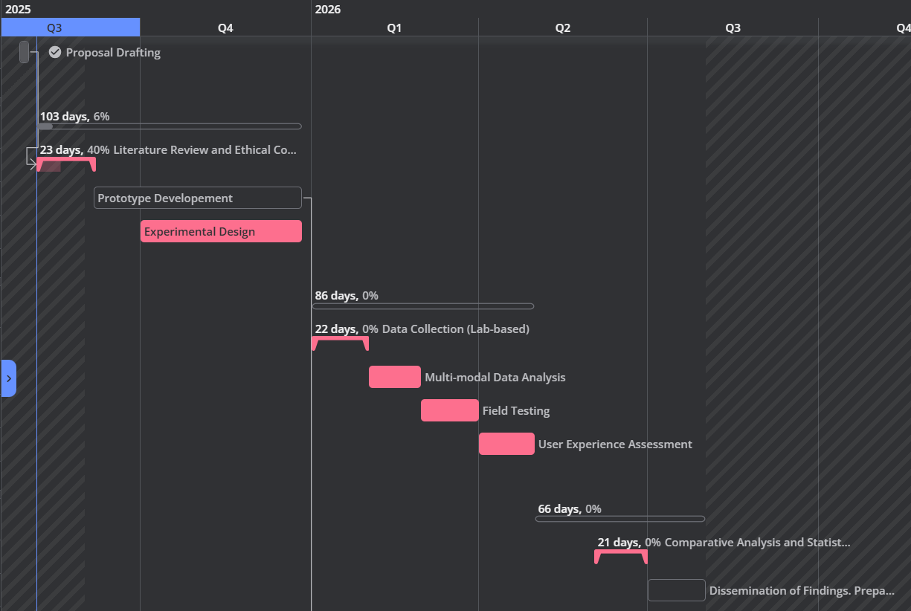
Phase 1: Planning and Development (August 2025 - December 2025)
This initial phase focuses on laying the groundwork for the project, from research to building the core prototype.
August - September 2025: Literature Review and Ethical Considerations. This is the foundational stage. You'll conduct a comprehensive review of existing research on driver monitoring systems. Concurrently, you should address ethical considerations, ensuring all data collection and privacy protocols are in place before any experimentation begins. Intellectual property survey for the AI driving monitoring system needs to be done.
October - December 2025: Prototype Development and Algorithmic Design. This is where the physical and digital systems are built.
Hardware System: Assemble the RGB camera, IR camera, Raspberry Pi, and CMS50E Pulse Oximeter.
Algorithms and Models: Develop and fine-tune the CNN, LSTM, NN, and rPPG algorithms. This includes addressing potential bottlenecks like environmental lighting, temperature, and vehicle stability.
October - December 2025: Experimental Design. Once the prototype is developed, you'll create a detailed experimental framework for lab-based testing. This will include defining simulated driving scenarios and methods for assessing driver fatigue.
Phase 2: Testing and Analysis (January 2026 - April 2026)
This phase involves collecting and analyzing data, both in a controlled environment and in the real world.
January 2026: Data Collection (Lab-based). Using the prototype and the experimental design, you'll collect data from participants in a simulated environment. This will allow for initial testing and refinement of the system.
February 2026: Multi-modal Data Analysis. You'll implement your machine learning algorithms to analyze the collected data, extracting features and classifying driver readiness. This is a critical step in proving the system's viability.
March 2026: Field Testing. Take the system out of the lab and conduct real-world testing with a diverse group of drivers. This will provide valuable data under actual driving conditions and help you identify any unforeseen issues.
April 2026: User Experience Assessment. Gather feedback from the field test participants. This qualitative data is crucial for understanding the system's usability and identifying areas for improvement.
Phase 3: Validation and Dissemination (May 2026 - July 2026)
The final phase focuses on validating your findings and preparing the project for public presentation.
May - June 2026: Comparative Analysis and Statistical Validation. Compare your system's performance against existing technologies and use statistical methods to validate your results. This step adds credibility to your findings.
July 2026: Dissemination of Findings. Prepare and disseminate your research findings. This includes writing academic papers, preparing for conferences, and creating presentations for stakeholders in the automotive industry. File a patent for the developed driving system.
Appendices
[1] S. G. Ahmed, K. Verbert, N. Zaki, A. Khalil, H. Aljassmi, and F. Alnajjar, “AI Innovations in rPPG Systems for Driver Monitoring: Comprehensive Systematic Review and Future Prospects,” *IEEE Access*, vol. 13, pp. 22893–22918, Jan. 2025, doi: 10.1109/ACCESS.2025.3535540.
[2] Preparatory Office of Personal Data Protection Commission, "Personal Data Protection Act," Laws & Regulations Database of The Republic of China (Taiwan), Dec. 25, 2018. [Online]. Available: https://law.moj.gov.tw/ENG/LawClass/LawAll.aspx?pcode=I0050021. [Accessed: Aug. 6, 2025].
[3] Sung EJ, Min BC, Kim SC, Kim CJ. Effects of oxygen concentrations on driver fatigue during simulated driving. Appl Ergon. 2005 Jan;36(1):25-31. doi: 10.1016/j.apergo.2004.09.003. Epub 2004 Oct 31. PMID: 15627418.

